

CREDIT CARD AUTHORIZATION FORM

PLEASE FILL OUT AND COMPLETE THIS AUTHORIZATION AND RETURN WITH YOUR VENDOR APPLICATION OR SPONSOR BROUCHURE TO [OFFICE@SNMSTATEFAIRGROUNDS.NET](mailto:OFFICE@SNMSTATEFAIRGROUNDS.NET) OR TO SNMSFR, PO BOX 1145, LAS CRUCES, NM 88004

NAME __________________________________________________________________________

NAME OF CARDHOLDER: _______________________________________(AS IT APPEARS ON THE CARD)

BILLING ADDRESS: ____________________________________________________________________

CITY, STATE, ZIP CODE: _________________________________________________________________

TELEPHONE #: ________________________________________________________________________

CREDIT CARD TYPE: _____ VISA ____ MASTERCARD ____ DISCOVER ______ AMEX ______

CREDIT CARD NUMBER: ____________________________________ (PLEASE PRINT CLEARLY)

EXPIRATION DATE: _____________________

BILLING ZIP CODE: _____________________

CARD IDENTIFICATION NUMBER (3 DIGITS LOCATED ON THE BACK OF VISA OR MATERCARD AND FRONT OF AMEX): ___________

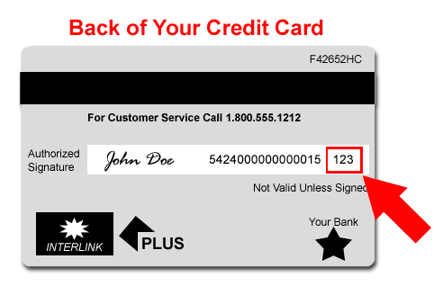

TOTAL AMOUNT CHARGED $ ___________

I hereby authorize Southern New Mexico State Fair & Rodeo to charge my card for the amount listed above. I certify that I am the authorized cardholder and I have full authority to make purchases on behalf of the account listed above.

SIGNAURE OF CARDHOLDER: ___________________________________ DATE:_________________

PRINT NAME: ________________________________________________________________________